### **AVL summary**

* AVL is a balanced BST.
* Maximal height is 1.44 * O(log(n)) = O(log(n))

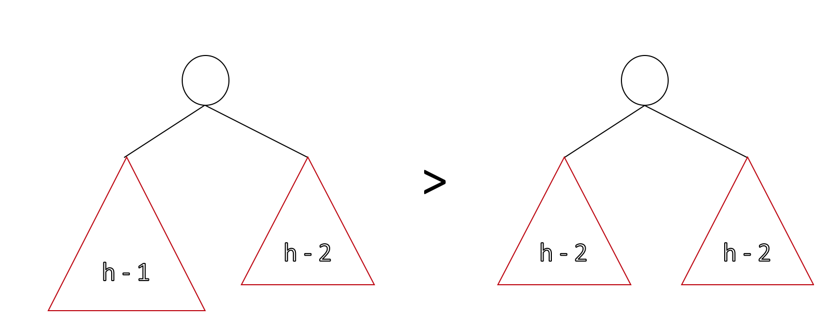

* The most important thing is that the running time is O(log(n)) for all operations.
* Number of rotations
  + **Find** → 0
  + **Insert** → up to 1 (L, R, LR, or RL)
  + **Delete** → up to h (O(lg(n)))

#### **Red Black Tree**

* + These are almost the same as AVLs.
  + Maximal height is 2 * lg(n) = O(lg(n)). //AVL is better
  + All operations run in O(lg(n)).
  + Constant time rotations for all operations → for red-black trees there can be a rotation during find(...).

|  |  |  |  |
| --- | --- | --- | --- |
| **Operation** | **Worst case running time** | **AVL Tree max Rotations** | **Red Black Tree max rotations** |
| **find** | O(h)=O(lg n) | 0 | 0 |
| **insert** | O(h)=O(lg n) | 1 | 2 |
| **remove** | O(h)=O(lg n) | h | 3 |

* + When we see “AVL” or “Red black tree”, we think about **Balanced BST** with O(**log n)** runtime on every operation

#### **Advantage of AVL (or Balanced BSTs in general)**

* + Running time for all operations O(lg(n)).
    - Improvement over: Arrays, Linked Lists
  + AVLs are great for specific applications when exact key is unknown:
    - Nearest neighbour search.
      * Nearby/nearest neighbor search: since when we zone into the data in the tree, we are close to the “nearby” data - so traversal is easier

#### **Disadvantages**

* + It is not O(1)
    - List has insertFront and insertBack with O(1) running time
    - lg(n) still grows as n grows.
    - If we have exact key, hash table runs in O(1).
  + All data has to be in the memory
    - All data must be in main memory which is bad for big data. For example, if the tree is on a server, the client must download the entire (left/right) tree for a search...
    - But we have B-trees are used to solve that problem!

#### **Standard Map in C++**

* + Balanced tree in C++ is implemented using red-black trees.
  + std::map<K, V> map; → this is a tree map, not a hash map.
  + Find: operator[](const & K);
  + Add: map[42] = “Hello”; → 42 is the key and “Hello” is the value.
  + Delete: map.erase(42);
  + **Range Traversal iterator**
    - There are two functions returning iterators:
      * lower_bound(const & K)
      * upper_bound(const & K) <- one past that element
    - Stopping condition: lower_bound == upper_bound.
    - Iterators are useful because they allow abstraction and make the syntax very clean.
      * In MP4 example: ImageTraversal & traversal = /* … */  
         for (const Point & p : traversal) {...}

### **Summary :: Every Data Structure So far**

|  |  |  |  |  |  |  |  |
| --- | --- | --- | --- | --- | --- | --- | --- |
| **Worst runtime** | **Unsorted**  **Array** | **Sorted**  **Array** | **Unsorted**  **List** | **Sorted**  **List** | **Binary**  **Tree (unsorted)** | **BST** | **AVL** |
| find | O(n) | O(lg n)  Binary search | O(n) | O(n) | O(n) | O(h)<=n | O(lg n) |
| insert | O(1)*  InsertEnd and resize properly | O(n)  Shifting up to ½ data | O(1)  InsertFront | O(n) | O(1)  Insert at root | O(h)<=n | O(lg n) |
| remove | O(n) | O(n) | O(n) | O(n) | O(n) | O(h)<=n | O(lg n) |
| traverse | O(n) | O(n) | O(n) | O(n) | O(n) | O(n) | O(n) |

*: amortized runtime

#### **Range based search**

* Consider points p = {p1, p2, p3, p4, … , pn}
  + What points fall in range [11, 42].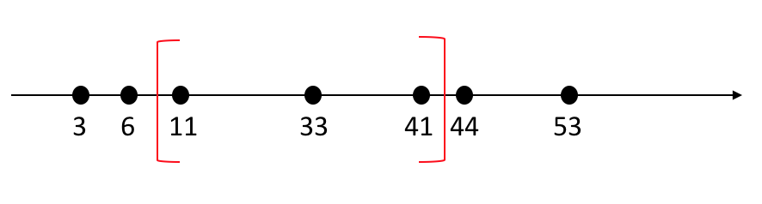
* Find lowest element, find highest point, and list all elements → lg(n) + k
* In order to compute this, we build a tree bottom up such that:
  + All nodes in TL ≤ data.
  + Data is contained only in leaf nodes.

Step 1: add all data to the leaves (there are as many leaves as there are data points).

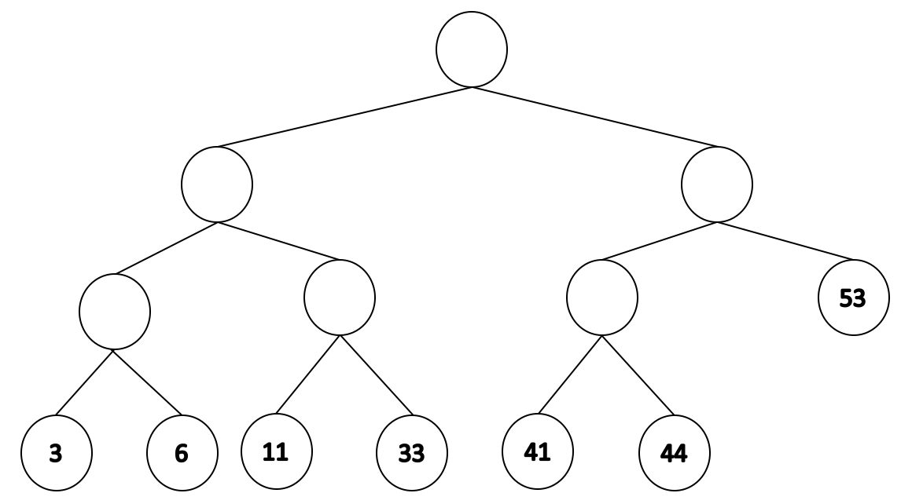

Step 2: Go to the parent and compute IOP from there. The IOP is the value that will be in the parent node.

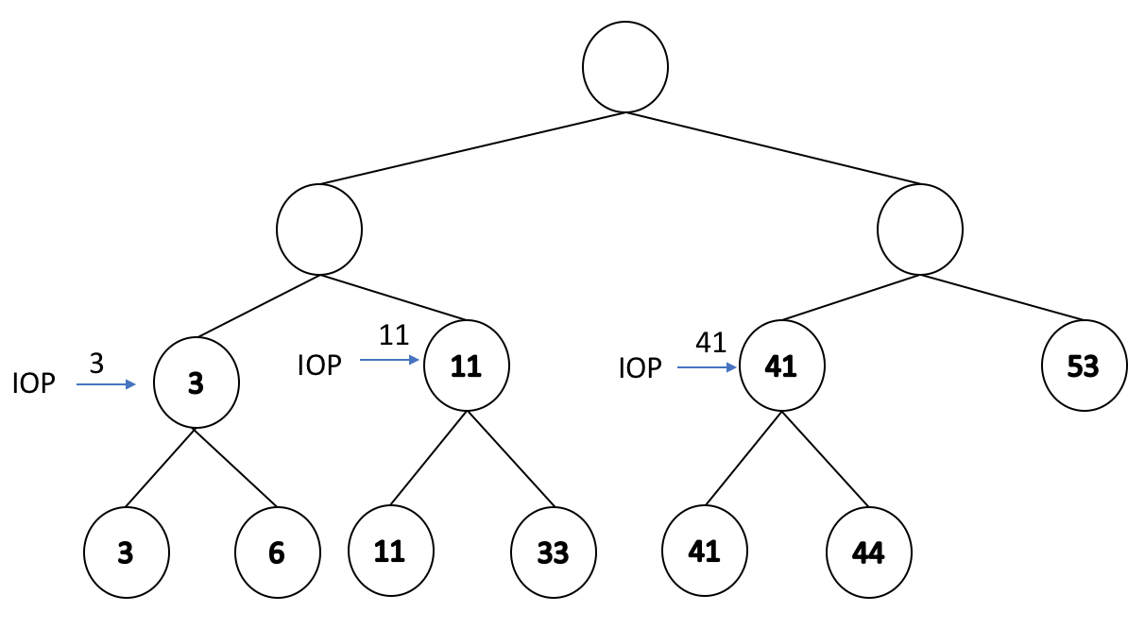

Step 3: Repeat step 2 as we go up the tree.

